**Phillips ( For medical )**

**Philips is helping close global healthcare gaps with mobile technology, such as its portable, app-based ultrasound solution Lumify, which helps medical professionals serve patients outside hospital walls. Lumify runs on the Philips HealthSuite Platform, supported by over a dozen AWS services such as** [**Amazon Kinesis**](https://aws.amazon.com/kinesis/) **and** [**Amazon S3**](https://aws.amazon.com/s3/)**, and supports a number of imaging scenarios, including heart, lung, abdomen, and Ob/Gyn examinations.**

* **Phillips Healthsuite** :-

Philips built its HealthSuite Platform on AWS to enable virtually unlimited scalability, faster time-to-market, and simplified privacy and security compliance for innovative healthcare and life science solutions. The HealthSuite Platform combines the power, security, and flexibility of AWS services with Philips’ healthcare expertise to bring innovation to the industry.

### **Philips Leverages AWS to Unleash the Power of AI for Clinicians and Patients:-**

Dr. Tina Manoharan, vice president (VP) of artificial intelligence (AI) and digital innovations at Philips shares insights on how the company builds on AWS using [Amazon SageMaker](https://aws.amazon.com/sagemaker/) to accelerate AI model development and deployment. These innovations deliver value to healthcare providers and patients by enabling quicker, more insightful diagnostics and timely interventions.

### **How MD Anderson and Philips Power Precision Medicine with Genomics on AWS:-**

As we learn more about cancer biology, clinicians can find it challenging to keep up with the pace of change and maintain an integrated, holistic, and informed view of the evidence. In this session, hear from AWS, Philips, and MD Anderson Cancer Center about tools and processes utilized to create the Precision Oncology Decision Support (PODS) solution as an expert-backed, evidence-based system to unlock this complex decision-making at the point of care. Using the Philips HealthSuite Platform (HSP), powered by AWS, clinicians can receive a unified view of therapies and clinical trials with the combination of genomic markers to aid an informed treatment decision.

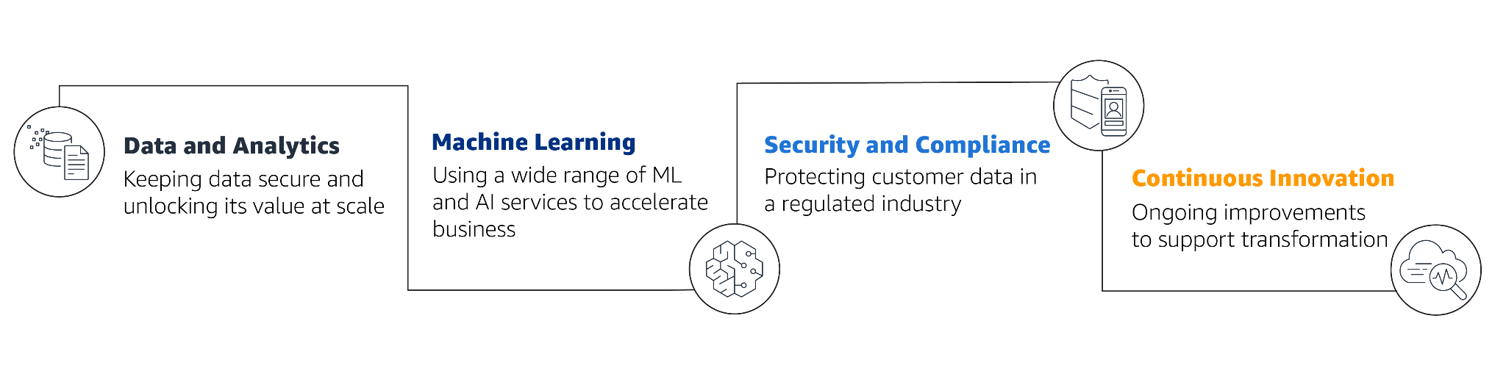

**Pinterest (For Advertising and Marketing )**

* **Before:-**

Pinterest is a visual discovery engine that hosts billions of images for over 450 million users to explore, save, and share as “Pins” to personalized digital inspiration boards. Born in the Amazon Web Services (AWS) Cloud, Pinterest can scale processing, storage, and analysis of its rapidly increasing data, all while reducing infrastructure management and focusing on innovation.

* **After:-**

Using compute solutions from AWS, Pinterest migrated its iOS continuous integration and continuous delivery (CI/CD) pipeline from on-premises to reduce build failures by over 80 percent. Pinterest also uses machine learning (ML) to power its visual search tool Pinterest Lens that can recognize over 2.5 billion objects and match them to products. Today, Pinterest’s exabyte data platform runs entirely on AWS, scaling log search and analytics to over 1.7TB while reducing operations costs by 30%.

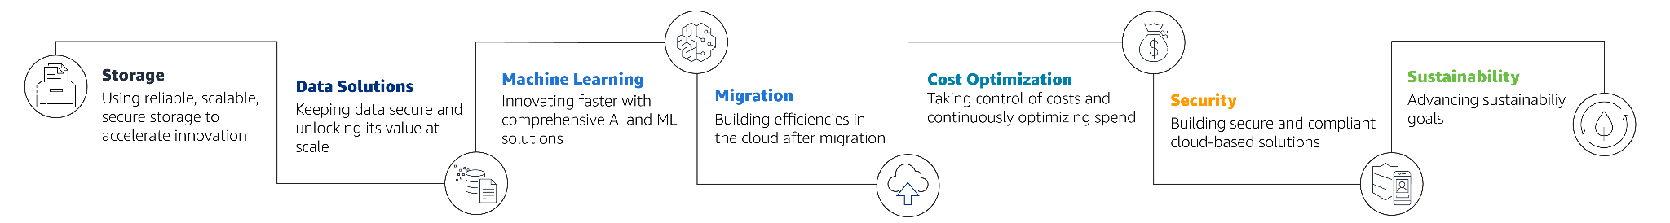

**MOSTLY ALL THE TOP AND EMERGING COMPANIES USES AWS FOR THE FOLLOWING REASONS**

* **Storage ( Reliable and Secure )**
* **Data Management and Efficiency**
* **Cost Optimisation and no upfront costs**
* **Security and Sustainability**
* **Focus on the USP of the product rather than the efficiency and management**